

IIT ASSESSMENT 3

Group 5 – The Technocrats



AUGUST 23, 2020



# Contents

Contents 1

Personal Information 2

Group Processes 5

Career Plans 5

Tools 8

Project Plan/Description 9

Overview 9

Detailed Description 12

Roles 17

Scope and Limitations 18

Tools and Technologies 18

Testing 19

Timeframe 20

Risks 22

Group Processes and Communications 23

Project Artefacts 23

Skills and Jobs 24

Dev Ops Manager 24

Technology and Hardware Research Analyst 26

How to Apply 26

Compliance Testing and Risk Analyst 27

Market and Technical Researcher 29

Group Reflection 30

References 34

Appendices 35

Software Wireframe Gallery 35

Companion App Prototype Gallery 38

## Personal Information

### Joe

#### student ID: S3862471

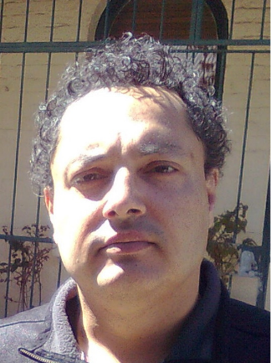I first became interested in programming when I had to do an assignment on BASIC in year 9 in high school, which led to my talking my parents into buying me a Dick Smith System 80 with 16kB RAM and an audio tape drive. I started programming in BASIC on it, writing various games and working on one in particular that helped me learn about subroutines.

In 1982 I finished a year student exchange program in the USA where I studied BASIC and got 100%. I did a course in Pascal in 1983 and started a degree in Mechanical Engineering at the University of Technology, Sydney (UTS, then the NSW Institute of Technology) in 1984 where I learned Fortran and dabbled in some other programming languages (Ratfor, Z80 Assembly code, Forth). I had to withdraw from the course before I finished. In 2010 I had another go at Mechanical Engineering, at Sydney University this time. In first semester I did Engineering Computing which covered Matlab. September last year I had to withdraw from the course having completed 89% of it. I have some experience in HTML and had a web site which made use of HTML and CSS but that is gone now. I also started a course on Udemy in writing applications for iOS, but I didn't complete it as I prioritised my university studies.

### Marcus

#### student ID: S3735636

I am a 22-year-old who has little interest in IT, with no experience whatsoever. I love video games; I recently built my own gaming PC and I like to work out how things fit together. However, that is as far as my knowledge goes. My family used to have one desktop computer that we could use for 30 minutes each a day, and whenever the phone rang it would cut the internet! The career I am pursuing has very little IT related skills necessary, I would not normally do a subject such as this however my business course requires it. In saying that, I have learnt a lot from this subject that I may be able to apply in my further studies as well as my career. My main hobbies include sports such as basketball, footy and video games.

### Murray

#### student ID: S3862651

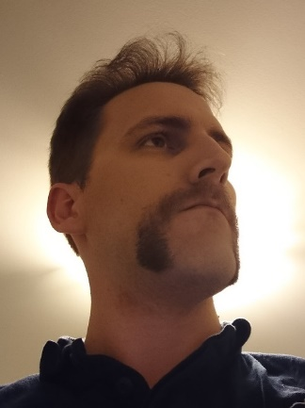My IT experience prior to this course has been mostly from simply playing around with my own computers and gadgets and doing some free online programming courses. When it comes to the technology I use, I like to explore and test everything I can, whether it be learning new programs or trying new ways to use gadgets. For instance, streaming my computer to the living room then using a Bluetooth PS4 controller with 3rd party software to watch Netflix, or myriad other token exercises. For me, half the fun is seeing if I can do it.

### Ossama

#### student ID: S3868543

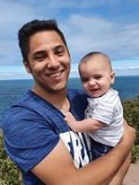I have always been interested in computing technology for as long as I can remember. Growing up we always had a computer in the house, and I found myself being the go-to person for technology related issues. As time went on and I developed an interest in gaming my competence within computing also expanded as a result. I am nowhere near adept in the area, but my interest and desired career naturally line up as a result.

### Torin

#### student ID: S3863563

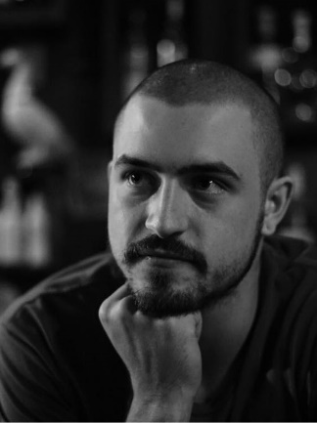My interest in IT goes back to some of my earliest memories at home. I remember our old dial-up connection beeping away, taking so long to produce even an image. LimeWire and Torrents came next, accidentally downloading viruses onto the family computer, while only trying to get a few songs on my 512mb mp3 player. At the local Trash & Treasure I would often find old computers to take apart and check out their insides. Removing the fans to connect to 9v batteries was always exciting. Later in life I found an interest in graphic design, sound engineering and a small amount of coding through internet courses. The graphic design was a creative outlet for me, as my pen to paper art skills are sub-par at best. My interest in live sound led me to connect two of my passions, technology, and music. Most recently, I have begun to delve into the world of coding, which brought me to this course.

### Tyson

#### student ID: S3756051

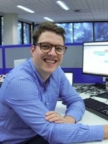I have always had a passion for computers and IT in general, I never took a traditional path but even in my career working in Building Services I found a way to utilize my passion for technology and have ended up working in building technology. Over the last 12 years I have been able to take a start as an apprentice to now leading a global team for Siemens as a digital expert. In building technology you have a need for varying skills, you start with the building services, understand how a building works and how its controlled. Once you have a foundation of understanding you can begin installing the automation system, this is installing hardware and sensing equipment throughout a building to control all the mechanical systems. It requires a level of knowledge for programming, electrical wiring, and networking. The programming and networking are the same as a typical computer system and very transferable skills.

It is clear to me that I am not a traditional learner, I can be very creative but also doing standard book learning exercises is not my ideal method. I work well in teams and can be very inclusive and attentive to others’ needs.

I really can work with most groups and can be a good leader or follower, I am good communicator and can bring people along the journey.

A group should form with different personalities and mixing the workload to fit each person. Being inclusive and understanding of skills and preferred tasks will be critical to success.

### Summary

Marcus was a bit of the odd one out in terms of IT experience, the rest of the team having some IT experience in software and/or hardware. Torin proved his own with his film-making skills in Assessment 5, the video production. Over all the combination of skills represented served the team well, although the combination of software skills available between Joe, Murray, Tyson and Ossama to some extent will serve us better in the development of this project beyond what we will be submitting for Assessment 3 and into the development phase.

## Group Processes

For assignment 2 our group took a couple of weeks to come together and coordinate before we could make a meaningful start and we encountered several issues impeding progression. We used the below solutions (often in an ad hoc manner) to get assignment 2 across the line:

* Used canvas for initial discussion before moving to MS Teams
* Files generally uploaded directly to MS Teams for a single member to upload to GitHub and incorporate into report
* Unstructured irregular meetings
* Relied up on direct messaging often making it difficult to reach team members
* Work was conducted mostly independently. Sections were split between members with little interaction, generally needing a high degree of editing/formatting to unify sections into ultimate report

For assignments 3 and 5 we applied the lessons we learnt from Assignment 2, building upon and adding to these methods after gauging what worked and where we needed to improve. We ended up implementing the following:

* Used MS Teams voice chat and screen sharing abilities in addition to text chat. This made individual input more recognisable and made for a more inviting forum to discuss ideas and problems. The visual interactivity made it much easier to convey ideas, helped improve group relations and fostered cooperation
* Our team worked together to understand the GitHub app and learn to update repository independently
* Rich text files (such as the main report) were stored on MS Teams while under construction. This allowed multiple members to edit the report simultaneously and avoided clashes with pushes to GitHub. Keeping the report body on MS Teams’ made it very easy to discuss as all members could view and edit the report live. We also conducted polls in an MS Excel file using this method
* A template report was created at the very beginning and sections were colour coordinated for each member’s contributions/requirements. This made sure no confusion arose as to allocation of responsibilities, allowing members to easily identify what needed to be done and in what timeframe. It also allowed us to monitor progress
* Regularly scheduled meetings twice per week kept members up to date with the changing scope of the project and prevented conflict between sections
* Established group accord to regularly check MS Teams for updates/member questions. Members often posted questions and received prompt responses helping to mitigate bottle necking
* Report guidelines laid out early based on the final state of assignment 2. This included general formatting, writing style, and referencing techniques used by all members
* Created a ‘member contribution’ text file accessible by all members. This was used to capture member contributions that could not be reflected by the GitHub commit trail

## Career Plans

### Joe

In Assignment 2 I said I was hoping to work as a software developer for a company that has products to help people with disabilities, and this hasn’t changed. I would also be interested in working for a non-profit organisation such as a church or a para-church organisation, something helping with the environment or a social justice non-profit or something similar, although with the economy being the way it is I way just have to take anything I can get, although being on the disability pension I can be more choosy than many people doing this course. I don’t *have* to work.

### Marcus

In Assignment 2 I stated that a job in the financial planning industry is my ideal career. This statement has not changed at all. While completing this subject, I have certainly discovered that I am not suited to a job in the IT field and I still believe that the financial planning role I mentioned in Assignment 2 would suit me best. This is due to the creative aspect of IT and technical skills that I have no interest in. I like the rules and regulations around the financial industry, and I like having structure. I also currently work in the financial industry and know it is the role for me.

### Murray

In previous assignments I stated that I am interested in programming and cybersecurity as potential careers. Time spent in the ‘Introduction to Programming’ course has reinforced this opinion as I find myself very much enjoying the creative problem-solving skills it utilises. The main attribute that I am looking for in a career is at least some degree of creative freedom, which I believe would be attainable as a software engineer, though cybersecurity may offer more in the way of day to day variety.

### Ossama

As previously mentioned in both assignments my ideal job has been to work in customer service and this assertion has not changed thus far. As I am being exposed to the wide world of Information Technology my desire to keep my career goals attainable and my future ambiguous still seems like my best course of action. This field of IT is still my first recommendation and is still a good steppingstone toward a career in IT.

### Torin

Throughout the weeks, after submitting Assignment 2, I have had time to contemplate my place within the IT community and whether it reflects my ideal career scenario. Without a doubt, this course has been a humbling experience, though my ideal career hasn’t shifted. In fact, gaining experience with online communication tools has made my vision for the future more accessible. The skills I've been learning are ultimately pushing me toward my original goal.

### Tyson

During this course I have found a reaffirming of my passions and what job interests me the most. My ideal job is based around creating a digital blueprint for a business to collect, understand, utilize large amounts of data to enrich the decision-making process. I am passionate about this and completing this course is only reinforcing my belief.

The specific job I previously found is based around bring business units together under one goal of data transparency. It is a complete process for a digitalization overhaul, working from design to implementation and ongoing management. It would be a very technical role but mixed with a large change management process. You would need to convince many parties of the benefit, create a solution that can be utilized across divisions and then implement the value of having data from all divisions using analytics.

I am interested in this role because it lends to my existing skill set, future skills I am currently building but most importantly my interest in Digitalization.

The following experience is required:

* Executive level exposure, on sales, reporting and management
* Design, development and validation experience on a digitalization strategy with analytics
* Engineering and Integration experience with cloud solutions like AWS/Azure with analytics roll out, including on-prem to cloud solutions
* Creating a comprehensive and clear communication message to work with a diverse set of team members

### Summary

There are some similarities in our ideal jobs that are quite apparent while other jobs contain similar elements if nothing else. Our desired branches of IT contain business, software, customer support and even finance. Although these workplace sectors can seem worlds apart the beauty of Information Technology allows for diverse opportunities for people involved with IT.

Out of the 6 of us sharing this project almost all of us have significant similarities with at least 1 other member between our desired jobs. Murray, Joe and Torin are all seeking a career in software development albeit in differing facets. Marcus, Tyson and Ossama are all interested in combining IT with business in some form or another. Marcus being inclined to use IT within the world of finance and Tyson with data analysis and retrieval. Ossama on the other hand wishes to use his IT experience alongside his customer service experience in a helpdesk or service role.

Expected in software development is a hefty amount of programming which is likely not what Ossama, Tyson or Marcus will be employing. It is more probable they will be using software developed by programming inclined employees such as Torin, Murray and Joe. Customer service will be front and centre for Ossama and Marcus which is a skill the other four are likely to never need.

After receiving our feedback from assessment 2 it seems that our desired individual career paths have mostly stayed the same. The opportunity of getting familiar with the IT industry and beginning to understand the likely job responsibilities has seemingly emboldened our resolve to follow in our pre-determined career paths. Aptly put by Torin, “Without a doubt, this course has been a humbling experience”, is an accurate summary of most of our opinions as we close out our first IT subject. Getting familiar with the kinds of applications such as Microsoft Teams and GitHub has revealed to us the immense knowledge, we have yet to possess to achieve our career goals. GitHub being the epitome of a complex and time-consuming starting point, which is a process of learning we will have to become accustomed to.

# Tools

### GitHub Member Commit Audit

The commit trail on the GitHub repository is largely not indicative of member contribution to this assignment. As detailed under the ‘Group Processes’ section, much of the work for some members was contained entirely within this report document, which was hosted on MS Teams but not on GitHub. This meant that those members had no cause to commit anything to GitHub directly. Additionally, of the members who were directly pushing to the repository, some made frequent small pushes while working on a task while others waited until entire sections were completed before making any pushes, further skewing the commit trail.

### Repository

<https://github.com/MurrayLowisRMIT/IITAssignment03-05-TheTechnocrats>

### Website

<https://murraylowisrmit.github.io/IITAssignment03-05-TheTechnocrats/>

# Project Plan/Description

## Overview

### Topic

Our proposed project is for an automatic household aquarium climate control system which is modular in nature. This device contains a central control hub computer equipped with a user interface to operate a set of tools. The modular design allows the user to customise and fit the instruments to their specific tank’s requirements for maintenance and automation. Hence, its utility is broad and allows it to operate for a multitude of different kinds of fish species. As previously mentioned, the control hub is the access port for the user to setup the aquarium to their specific needs via software, we plan on developing. Included in the software is a system that lets you track your aquariums and fish individually and make changes if needed. This program also includes information and instructions on how best to take care of the myriad of species catalogued within the software. By using this setup users will likely no longer have to:

* Maintain correct temperature within the tank
* Manually feed the fish (However refilling feeding reservoirs will be required)
* Adjust pH levels manually
* Manage water levels (against evaporation)
* Test and adjust chemical concentrations
* Apply correct lighting per species requirement

Its intention is to electronically streamline the tedious, complicated, and time-consuming processes of fish care, while also enabling users with applicable upkeep instructions. Granted a successful development stage, the result would have users able to appropriately care for their fish with applicable information, suitable food, and a healthy habitat for the fish to thrive.

### Motivation

The objective for this project is to mitigate the struggles faced by novice aquarium owners and minimize the chances their tanks become a watery grave. For experts, this project will provide the convenience of automating the more tedious tasks. Most people that obtain fish and an aquarium do so without fully comprehending the extensive responsibilities and intricacies of nurturing fish successfully.

Installing a filter and filling the tank with tap water seems simple enough, but only the more researched owners would be aware of the risks such little effort endorses. Fish can be extremely sensitive to environments that are unnatural to them, hence why slight temperature changes is often enough to kill them. Informing new aquarium owners of the proper methods to care for their scaly friends is likely the most important aspect of this technology. Informing them, step 1. Automating the work, step 2. This seems to be the most direct way for us to achieve our goal of limiting unnecessary fish stress or fatalities.

The automation in turn protects the species housed within, as owner unreliability and ignorance are much less likely to cause significant harm or death to the fish. Fish are usually able to live healthily for several years but their natural life expectancy is very often cut short due to poor tank management or ignorant owners. This device goes a long way in mitigating these issues. It is no secret that aquarium holders often neglect the laborious task of changing water, managing correct chemical balance, or maintaining correct temperature. It is also common for owners to introduce incompatible species to their tank putting all the fish in danger. Managing pH levels is another good example of a precise and complicated procedure to get right, and if not done correctly is one of the largest causes in fish death [1].

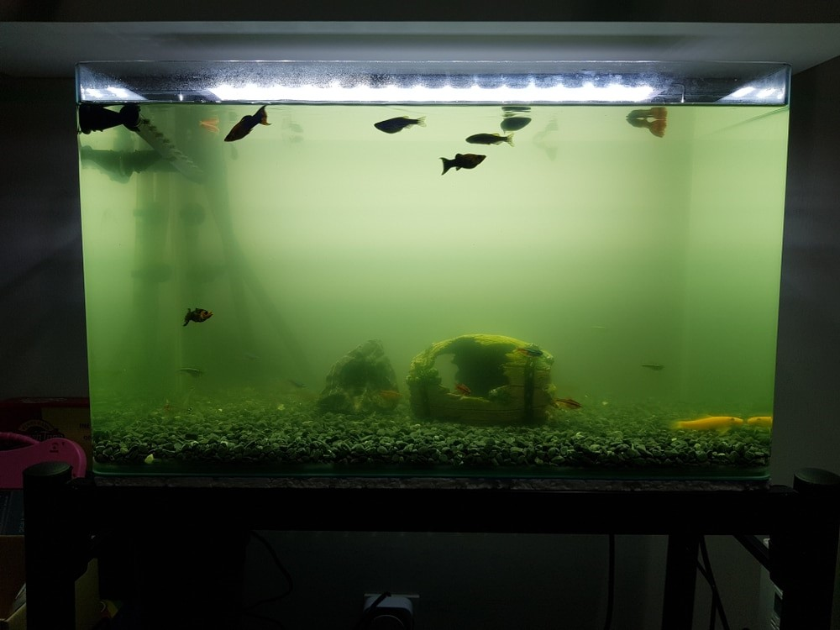

Poorly maintained aquarium [2]

We believe technology is at its best when used as a means to an end, and thus our ultimate goal is to modernize the laborious nature of fish raising and to counter futile fish mortality.

### Landscape

Looking at the state of modern electronic aquarium setups the biggest competitor and closest product to our own design would be the GHL Profilux 4 Aquarium Controller.

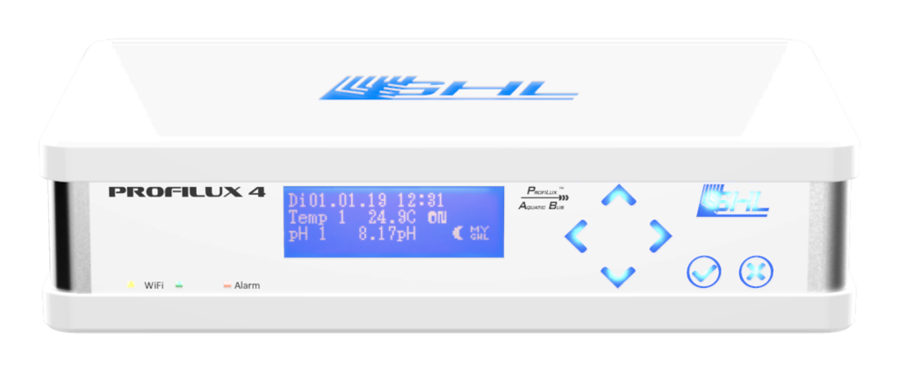

The GHL ProfiLux 4 [3]

Similarly, to our own ambitions this device also contains modular connections for varied aquarium configurations. These connections can handle temperature, pH levels, lighting, feeders, and water level monitors. The companion application, GHL Connect App, allows the user to individually fine tune the complex attributes of an aquarium arrangement. Due to its inherently complicated and fiddly design this device is purely marketed toward aquarium experts and budding aquarists. As stated in their tagline “The ProfiLux® aquarium controller offers everything the ambitious aquarist needs to achieve success”. [4]

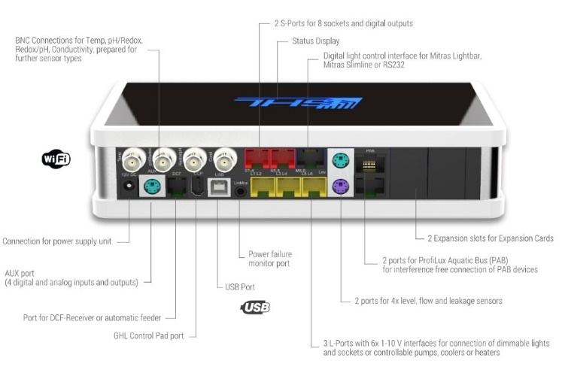

Rear connections [5]

A key difference to note is the method of using the devices. The GHL Profilux 4 requires a separate companion application operational through a smartphone or computer linked on the same network to control, whereas our Robo Reef if directly controllable via a central control hub computer accessible via a user interface as well as a companion port application to fit the users convenience. The interactive encyclopaedia housed within the Robo Reef is another important distinction between the two. The GHL Profilux 4 assumes the users understanding of the fish or at the very least expects them to have already completed prior research before modifying the particulars. The Robo Reef, however, makes no assumptions about the customers awareness and provides the relevant information thus making the device safe to use and optimal from the very day a new fish arrives.

With such opposing marketing strategies, we believe there is still a hefty market for the Robo Reef to capitalise on. As previously mentioned, the Robo Reef’s design is to appeal to the fish raising novice by providing extensive species information and streamlining the alterations. Combining the fish requirement details with the ability to make quick and automated modifications encourages beginner clients to sustain a healthy habitat for all within.

## Detailed Description

### Aims

The ultimate deliverable for this project will be to release a mostly autonomous, modular climate control system for household aquariums. The minimum amount of progress required to consider version 1.0 viable would be for the central control hub computer to be operational, have a simple user interface, and support a limited list of fundamental instruments. These core deliverables are broken down below:

* Functioning hub computer
  + Construction of the physical hub (including expansion ports for instruments)
  + Software for user interface (most likely touchscreen)
  + Ability to control instruments through interface
* Suite of starter instruments for a basic tropical fish tank of a predefined size
  + Thermometer/heater
  + Basic filter/aerator set up
  + Lights/timers
  + Auto-feeders/timers

While the above features would constitute a technically complete project, it is only a starting point. Once the functionality of these core components has been demonstrated, effort can then be directed toward additional features which would improve or diversify the functionality of the system. The outline of proposed additional features is laid out below:

* Support for different sizes/types of the above core instruments to suit other sizes/types of aquarium
* Development of less ubiquitous instruments
  + Water level sensors/autofill instruments
  + pH sensors and regulators
  + Nitrate/nitrite/ammonia sensors and regulators
  + General hardness and carbonate hardness sensors and regulators
  + Various aerators (both independent and cooperative with filter)
  + Light intensity sensors/adjustable lighting
* Support for easily integrated 3rd party instruments such as lights and heaters
* Create and populate interactive encyclopaedia covering:
  + Species individual requirements
  + Species compatibility
  + Aquarium establishment methodologies
  + Information and advice about potential issues including diseases and pest outbreaks (snails, duckweed etc.)
* Develop a companion app for smartphone/pc etc.
  + This would essentially a clone of the hub software ported to other devices
  + Wireless interactivity with hub for remote control

### Plans and Progress

#### Inception and overview

The conception of this project was first born from Murray’s experience with caring for personal aquariums and all the problems faced on the path to successful care and management. As a group, The Technocrats decided this would be the perfect scenario to take advantage of the global knowledge pool and automation techniques made available through modern IT.

The original proposal for this project was just a simple all-in-one premade tank with a built-in set of instruments to suit a rigid, restricted single use case. This model was ultimately deemed insufficient on the grounds that there is already a multitude of prebuilt aquariums on the market (many of which enable woefully inadequate levels of care), and to an uninformed novice this would just appear to be an unnecessarily convoluted alternative (“Why should I pay $200 for all these extra doohickies when the $20 one says it does the same thing?”).

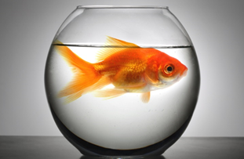

“But the guy at the pet store said this was fine” – Local boy, 9 [6]

Furthermore a single setup would never be able to accommodate the different needs all of the different species kept in modern aquariums or satisfy the varying practical and aesthetic requirements of aquarium owners (“How am I supposed to keep seahorses in a tank with a filter current too strong for them?” or “I need a tank that can fit on my small living room table”).

The solution to these problems was to adopt a modular design built around a universal control hub. This will allow the user to mix and match the components for their tank to suit whatever their use case may be, whether a tiny filter and heater set up for a single betta fish or a sprawling, room filling system comprising multiple sub-climates and a self-contained ecosystem.

Providing the right tools however is only half the job, they become useless without an understanding of how and when to use them. For this reason, the project will include a digital encyclopaedia covering everything from species needs to aquarium set up tutorials which will allow the user to make informed decisions every step of the way. Since this information obviously needs to be made available before purchasing everything, this software will be made available as part of a free companion app.

After the now-informed user has established their new aquarium using the modules advised for their designed setup, ongoing maintenance of the aquarium would then be managed by micro controller. The micro controller (Arduino modified) would host a Linux operating system modify to act as a web server for the application allowing local non-internet access or via our web portal. This allows our users to utilize any device to setup and manage your aquarium. The ideal use would be through phone so you can utilize your camera to add sensors via our QR input method.

Initially Bluetooth connectivity was considered to connect the app and hub, however this was decided against due several issues with the Bluetooth environment. These flaws include the need for physical proximity which would mean make the monitoring functions of the app redundant but would also would not allow the user to receive alerts and send intervening commands when not nearby. Bluetooth is also often susceptible to interference and can at times be temperamental.

#### How It All Works

The entire system is centred around the main hub device which controls how every other part of the system operates, taking inputs from the user, dictating the functions of connected modules and providing feedback to the user when requested or when their attention is required.

The user interface for the hub computer will be via a responsive web application hosted on the hub computer, this can be accessed locally offline via a static IP address or online through our website, the prototype layout for which can be found in the "Project Artifacts' section. The functions performed by the various instruments within the tank will be controlled by the hub computer based on the inputs given by the user, who will in turn be advised by the built-in digital encyclopaedia and tutorials. The hub will continuously monitor the conditions within the aquarium by taking the readings from the connected sensors and comparing these against thresholds defined user input. When thresholds are exceeded, the software vary its output to the relevant instrument to modify its behaviour, for instance reducing power output to the heater if the thermometer reading exceeds the maximum allowable temperature. If no relevant instrument has been installed into the system, it will instead send an alert to the user via an onscreen notification, playing repeated warning ‘beeps’ to catch the user’s attention, and sending a push notification to the companion app if the user is using it.

The built in digital encyclopaedia will include searchable details for a wide range of fish, plant, and other aquatic species, tutorials for the establishment and management of their current aquarium and other aquarium types, and other relevant information such as the handling of disease outbreaks or pest infestations.

Should the user opt to register their system online, they will be able to take advantage of the companion app to control and monitor the aquarium remotely. The companion app will run a similar version of the project software built into the hub computer but will function as a virtual instance of the hub computer. Rather than controlling the tank instruments directly, the app will relay hub readings to the user and user inputs to the hub which will then modify instrument operations.

This online system will take the form of a dedicated server to record user preferences, relay aquarium conditions to the user on any given device, and remotely manage the hub’s output the tank instruments.

As for the physical instruments that make up the modular components of this system, early development will be focussed on the simpler and more ubiquitous instruments. This will include thermometers, heaters, feeders, lights, and filters.

Digital thermometers will be wall mounted within the body of the aquarium and connected directly to the hub via the connection ports. The temperature readings will be taken as an input by the hub computer and the readings made available to the user. This input will also be used by the hub to regulate the output provided to heaters if they have been included in the tank. The heaters output will be increased, decreased, or unchanged depending on whether the current temperature is below, above, or equal to the target temperature set by the user. The heaters themselves can be made available in several varieties including wall mounted, under-tank, or under-substrate. For larger setups, multiple heaters and thermometers can be used to unify temperature or to manage areas separately throughout the tank if desired.

Lights will be available in several varieties and sizes to account for tank needs. Variants will include basic white, UV light, and full spectrum lighting and be available in top mounted, suspended, or boom arm varieties. All lights will be LEDs for durability, efficiency, and safety. The lights will all be controlled by the timer built into the hub computer which will allow the user to set daily schedules with additional options to simulate natural sunrise and sunset or other ambient options such as thunderstorms and cloud movements which can be relaxing to both the fish and owners.

Different types of filters will make up the final category of the ‘core’ instruments. The range of filters made available will include wall-mounted, under-gravel, and waterfall variants. The appropriate types for a given tank will be dictated by the species as laid out by the encyclopaedia, passive fish such as bettas for instance do better with the still water enabled by under-gravel filters, whereas certain tetras prefer a mild current that can be achieved with waterfall filters. For more advanced use cases, the hub computer will provide options scheduled outages or intermittent use such as in heavily planted tanks where a moderate degree of suspended biomatter can be advantageous.

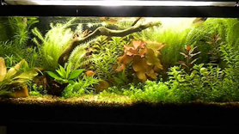

Heavily planted tank with low bioload requiring negligible mechanical filtration [7]

Once the core instruments have been satisfactorily finalised and implemented, further development can then turn toward secondary modules to expand functionality and add quality of life features. This will include automatic feeders, aerators (both independent and those that work in tandem with filters), water level monitors and controllable release reservoirs, and an assortment of water chemistry sensors or regulators to manage parameters such as pH, nitrates, nitrites, ammonia, general hardness and carbonate hardness.

Aerators are relatively simple devices, though come in several varieties and are not always necessary in many aquarium types, hence their relegation to secondary instruments within the scope of this project. The types that would be considered include air-stones, waterfall aerators, and other surface disturbing impeller varieties. Most aerators can simply be set for continuous operation, however certain use cases may require operation at reduced or intermittent intensity due to factors such as a reduced water level causing over-oxygenation by waterfall aerators (which can cause health issues such as gas bubble disease). These constraints would be handled by the hub computer. Many aerator variants would also be able to work in tandem with filters, passing impelled water through the filter before discharging.

Automatic feeders as a concept are quite straightforward, however due to the drastic differences between the different types of food and requisite release mechanisms this has been outlined as a secondary feature for now. The eventual implementation for these will incorporate mechanisms allowing feeders to handle food types including flakes, pellets, freeze dried livestock, liquids and fertilisers for plants, and potentially live food such as brine shrimp. These would need to be kept stocked and checked for freshness manually by the owner and a release schedule entered into the hub computer.

The various water chemistry sensors will likely be among the most complicated mechanisms to implement within the scope of this project due to their often-complex operation. Most commonly chemistry tests are conducted via manual chemical mixing and observation, whereas an automated system would likely require a repeatable, digitised approach such as custom developed sensor rods. For this reason, chemical sensors (and therefore also their corresponding mechanical regulators) have been set aside for later research and development. Once developed and implemented however, the sensors would run continuous or regular tests, feeding results back to the hub computer for processing and then releasing chemicals via the regulator mechanisms to correct water chemistry as required.

#### Progress to date and future development

At the time of submission for this report on August 23rd, project development has been primarily exploratory and conceptual. While the timeline for development has been outlined, the tangible assets created include the pseudo code for the hub and companion app software which was created using various webtools such as figma.com and lucidchart.com as featured in the ‘Project Artifacts’ section. While the software itself has not yet been developed, a limited number of entries for the digital encyclopaedia have been created for demonstration purposes.

## Roles

### Head Ops Manager - Murray

As the head of operations, Murray manages the overall goal of the project. The role requires him to manage and define roles related to labour, productivity, quality control, and safety measures. Along with analysing team operations, he is required to prepare and evaluate annual budgets, initiating corrective actions where necessary. While overseeing the overall vision of the project, the Ops manager must also have a deep understanding of the technical aspects and be able to communicate with the Development team on this level. Every project requires a leader to define and keep the team focussed, this encapsulates the Head Ops Manager position.

### Ops Assistant Manager - Ossama

As the Ops Assistant, Ossama works directly with the Head Ops manager. The main responsibilities of the Ops assistant are to aid the Ops Manager with daily tasks, recommend improvements to the project, liaise with different departments, and monitor cash flow and budgets. As a general manager of the project, excellent communication is expected in every facet of his job.

### Dev Ops Manager - Tyson

As the Dev Ops Manager, Tyson oversees Software Development within the project. This crucial position requires Tyson to communicate with the development team, defining specific roles, and monitoring productivity. As a manager, Tyson will work closely with the Head Ops Manager to examine and adjust operational logistics where necessary.

### Technology and Hardware Research Analyst - Torin

As a Research Analyst, Torin is required to explore technology and hardware options and consider which elements will be most useful for the project. He is expected to research, analyse, interpret, and present findings to the Ops manager. It is imperative for the research analyst to communicate relevant information to the Dev Ops manager, coordinating software and hardware requirements of the project.

### Market and Technical Researcher - Marcus

As a Market and Technical Researcher, Marcus works closely with Torin to explore technological routes for which the project will take. His position will aid the team in acquiring knowledge of relevant technology and competitors within the scope of the project. Marcus will be required to prepare and present research reports to the Dev Ops manager and Ops Manager.

### Compliance Testing and Risk Analyst - Joe

The Compliance Analyst will be required to evaluate risks with the products developed from the project through thorough and controlled testing. Joe will be required to develop and coordinate testing parameters, interpret data, and present the findings to the Ops Manager. Joe is expected to make suggestions based on risk analysis and test data.

## Scope and Limitations

The initial focus of the project has been set developing a single use case in a small freshwater aquarium with limited instruments, as outlined in the aims. While this leaves much room for expansion, due to the lack of relevant experience within the team, it was decided to restrict the focus to ensure enough time is committed to developing the fundamentals and that resources aren’t wasted on tasks lacking a clearly defined ultimate implantation. Development of these secondary features could be considered only after all core components have been successfully developed.

The lack of experience within the team also creates a few key limitations for developing the project. The limited programming experience within the team currently makes it impossible to properly develop the actual software for the hub or app beyond wireframes and ‘click-throughs’. The actual physical components will most likely require input from a 3rd party as the group entirely lacks the skills and tools required for the resourcing, physical construction, and interfacing of all the various components.

Certain aspects like procuring information to fill out the encyclopaedia and tutorials would also require much deeper research and possibly licensing issues etc.

## Tools and Technologies

|  |  |  |  |  |
| --- | --- | --- | --- | --- |
|  | LucidChart | GitHub | Figma | iMovie |
| Software License | Team License  $13/user/mth (min 3) | Enterprise License  $21/user/mth | Organisation License  $49/user/mth | Free |
| Previous  Experience | Tyson w/ RMIT and business application | All team members through previous Assignments RMIT | Tyson w/ RMIT and business application | Torin has a small amount of experience through secondary school |
| URL | <https://www.lucidchart.com/pages/> | <https://github.com/> | <https://www.figma.com/> | [https://www.apple.com/imoviehttps://www.apple.com/imovie](https://www.apple.com/imovie/) |

### LucidChart

LucidChart’s software was used initially to create a wireframe UI for the application so as to demonstrate and sketch out capabilities. Tyson has previous experience with the application through previous projects. The license for the software is competitive compared to alternatives.

### GitHub

GitHub is used as a collaboration software for the team aspects of the project. As the team all had previous experience it was chosen for this project. The enterprise license is well priced considering the vast functionality.

### Figma

Figma is an application demonstration software that Tyson had previous experience using. Though the Organisation is among the more costly options, we chose Figma for its intuitive functionality over alternatives.

### iMovie

iMovie is a video editing suite used for our video presentation. The free software from Apple is simple to use and suited our needs nicely. Other alternatives such as Final Cut are expensive and contain unnecessary functionality.

## Testing

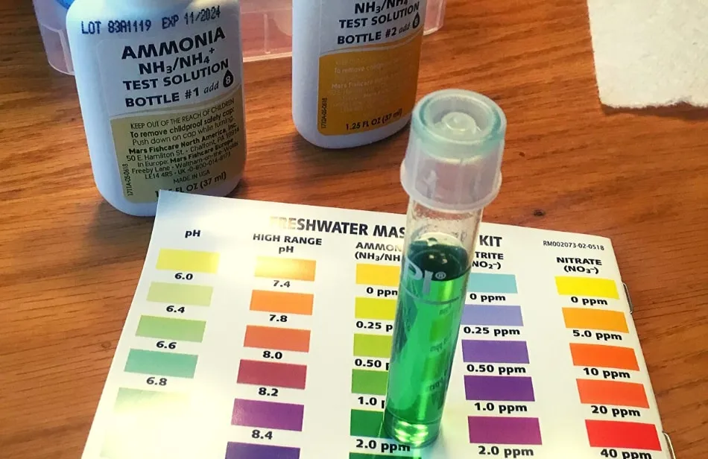[8a]

Stage 1 testing is pretty simple: Sensors: Temperature, Lights; we can test these with a simple thermometer and using our eyes. We will need to test for electrical leaks in the tank, tester to wear thick rubber gloves such as welding gloves while going over the tank with a multi-metre.

Stage 2 is where we’ll need to purchase some more advanced testing gear: Ph, water level, aeration (oxygen levels), hardness, nitrate and nitrite, ammonia, salinity, phosphate, [8] Test using no fish first, then ‘expendable’ fish. Start with a testing kit, such as the API Freshwater Master Test Kit [9], about $39 USD including delivery to Australia, and a refractometer to test salinity. Although we are initially looking at freshwater aquariums the Technocrats must make sure there is no saline build up [10], from about $150 USD [11]. The cost of the refractometer indicates the viability of our project as it is one of the savings to the customer who purchases our Robo Reef. Testing of the automatic feeding arrangements could be done using a measuring spoon.

The team will need to test the software, test the values in the encyclopedia, test the controllers for the tank, and conduct user testing with people unfamiliar with the project – with whom we will need to test that all the instructions are clear. Initial tests can make use of friends and family, say ten people for stage one, but the team will need to do a paid user test on a large number of subjects as the project nears completion for stage two, say 100 people. The team should look to including people with various disabilities in these tests.

The team will need to test in a variety of browsers on different OSs. Safari, Edge, Chrome, Firefox, and Brave, running on Windows, Mac OS, iOS, Android, and Linux. Testing on different devices should include desktops, phones, laptops, and tablets.

## Timeframe

Weeks 1, 2 and 3 consisted of assigning each team member a purpose and role. After assigning these roles we moved to deciding on the group’s aim and the scope of the project. Through this time, we decided on meeting times, and each member began their initial research for their respective sections. During week 3 each member had a clear idea of their direction and began actioning their individual tasks.

Weeks 4, 5, 6 and 7 began with determined progress on each section. Team members had time to reflect on the previous weeks work. Weeks 5 and 6 ended with the conclusion of the team’s first report. Valid risks and testing procedures were considered and solidified. The initial artefacts are created and demonstrated. In week 7 the team reflected on their progress and made adjustments depending on critiques from the other members.

Weeks 8, 9 ,10 and 11 begin with testing phases and back-end and front-end integration. The testing phases are underway with reviews at each interval. Hardware integration commences. At the end of week 11 phase 2 trials have commenced with constant monitoring from ops managers.

Week 12, 13 ,14 and 15 begin with the commencement of phase 3 trials and full integration of back-end, front-end and hardware integration. Each team member’s progress so far is audited, and all information is collated into the version 1 report. Final changes are made to software and hardware artefacts. As human trials come to a close, the team prepares any final changes to report for the version 1 public release. Version 1 is released end of week 15.

|  |  |  |  |  |  |  |
| --- | --- | --- | --- | --- | --- | --- |
| Name | Marcus | Murray | Joe | Torin | Tyson | Ossama |
| W1 | Initial meeting, Roles are chosen | Initial meeting, Roles are chosen | Initial meeting, Roles are chosen | Initial meeting, Roles are chosen | Initial meeting, Roles are chosen | Initial meeting, Roles are chosen |
| W2 | Competition research commences | Product research monitoring productivity | Identifying potential risks | Initial research into relevant technologies | Research into software development tools | Aiding in general research |
| W3 | Technical Research commences | Scope and limitations decided | Identifying potential tests | Familiarisation with relevant hardware & competitors | Development plan framework devised | Communication with team parsing information from each |
| W4 | Collaboration with other research assistants | Development tools briefing | Testing phase 1 report research | Report framework set out | Initial UI design set out | Overseeing testing phase  And initial wireframes |
| W5 | Report drafting begins | Risks consultation commences | Testing and risks report drafting | Drafting of technologies report | Drafting of framework and click-through | Research review and collating ideas |
| W6 | Finalisation of first report | Final drafting and editing to first report | First testing and risks report finalised | Final changes to initial technologies report | Finalisation of framework and click-though | Finalising aims and first report structure |
| W7 | Report revision. reflection and critiques | Report revision. reflection and critiques | Report revision. reflection and critiques | Report revision. reflection and critiques | Report revision. reflection and critiques | Report revision. reflection and critiques |
| W8 | Any adjustments made to initial research. | Collating and delegating for next stages in project | Phase 1 testing begins | Software and hardware manifest completed. | Click-through data transferred to HTML | Aiding in collating and delegating for next project |
| W9 | Continued adjustments and research | Meetings with each team member, continued communication between areas | Phase 1 testing continues | Revision on relevant software. Any changes made to suit new aims and scope | Front-end development begins, hardware implementation explored | Communication facilitated between each sector. |
| W10 | Additional areas explored. | Overview and auditing of phase 1 testing | Phase 1 testing ceases, report and reflection | Continued revision into new technologies | Continued front-end UI and UX  Designed | Any issues or communication breakdown ratified |
| W11 | Additional areas explored. | Overview and auditing of hardware and software integration | Phase 2 research commences | Hardware prototype development started in conjunction with back end team | Hardware testing and implementation continues | Prototype development overlooked |
| W12 | Additional areas explored. | Continued oversight on hardware and software integration | Phase 2 testing ceases and report findings implemented for phase 3 | Hardware development continues | Physical prototype loaded with software and trials commence | Communication facilitated between researchers and |
| W13 | Additional research commences upon completion of phase 2 | Review and auditing of phase 2 testing. | Phase 3 testing commences | Collaboration with Software developers, implementation continues | Software revised dependant on prototype functionality | Phase 3 testing oversight and facilitation |
| W14 | Collaboration with research partners. Test result comparison and review | Phase 3 testing review and auditing of integration procedures | Blind phase 3 trials commence with human subjects | Collaboration with Risks and testing officers to commence phase 3 trials | Continued revision dependant on prototype functionality | Facilitation and auditing of human testing |
| W15 | Purging of all research information into report | Final report editing, review and auditing to coincide with version 1 public release | Phase 3 trials finalise to coincide with version 1 public release. | Phase 3 trials finish with all information collated into release report | Final changes and release of version 1 public release | Final report and testing audit. |

### Marketing

Marcus will have the job of blogging on the company web site with informative information for aquarium owners as companies that blog receive 97% more links to their site than companies that don’t [12]. Also, Marcus will attempt to get interviews on popular podcasts such as Aquarium Myths and Secrets Revealed, Real Fish Talk by Aquarium Cooperative, etc. [12]. Marcus will be uploading the marketing videos such as the Robo Reef ad video to YouTube and maintaining an interesting video presence on YouTube as a higher percentage of Americans use YouTube than Facebook (73% vs. 68%) [12], although we will be building a Facebook presence as well, where hopefully our amusing videos will be shared widely.

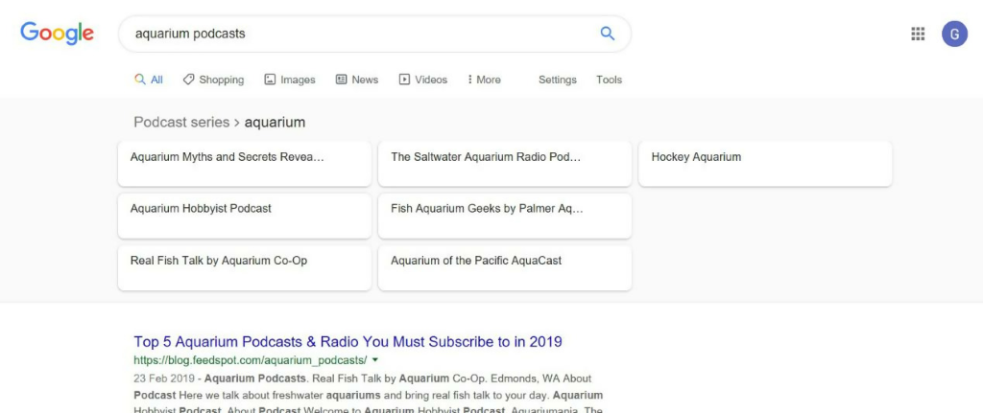[12]

## Risks

### Killing fish because of errors in sensors, programming, or controls

Short circuit making the tank ‘live’ – all electrical components in the tank should be stepped down from 240V & waterproof, risk of death from electrical shock. This is particularly the case with small children who may well put the leads in their mouth.

Some components will need to be under water, some partially immersed (heaters) and some out of the water (lights, air pumps) [13]. Leads should have ‘drip loops’ between the tank and the computer/device running the software, i.e. a loop of chord where the bottom of the loop is at a lower point than the connection to the device so that water dripping down the lead will drip off at that low point without reaching the device [13].

Injury on the corners of the tank, or from the tank breaking (sensors and controllers must be fairly lightweight). Risk of drowning, with respect to small children: the aquarium should be on a sturdy cabinet or proper aquarium stand suitable for its size and weight [13].

### Infringing the patents

This shouldn’t be an issue as this is a specialised computer system in the USA, not something that runs in a browser on multiple platforms anywhere in the world. It also doesn’t have the functionality of maintaining the tank’s ecosystem.

This also gives us a good price point for comparison; the GHL Mega controller retails at $879.90 USD [14], if we can’t get our product out for about that amount, we will risk:

* Pricing ourselves out of the market. By keeping an eye on development costs and avoiding cost blowouts we should be able to avoid this, particularly having GHL Mega controller price point for comparison.
* Not being able to source information for the encyclopedia, or all the skills necessary to develop the product. Although both these issues can be worked around by hiring others or acquiring the rights to use current fish encyclopedias, the costs of underestimating what they will cost us would make the team more likely to price ourselves out of the market.

## Group Processes and Communications

There were problems in communication early on. Time restrictions for those who are working made it difficult to contribute in a timely manner, particularly the 1 ½ weeks after the submission of Assessment 2. We used Microsoft Teams for group communication and file sharing, as well as a GitHub repository. There were problems in overwriting other people’s work. Murray has had to go back through the ‘commits’ and merge one person’s work with that of someone else, so as of 14/08/2020 we elected to make it that edits to the Report were on a live version posted on Teams.

There were problems in missing aspects of the criteria in Assessment 2. All of us read over the criteria on multiple occasions for this assessment. We voted to determine the best times for meetings, the team name, and the product name. In some cases it was difficult to get everyone’s vote in a timely manner.

## Project Artefacts

For our project we decided on two types of artifacts:

1. Wireframe
2. Prototype

The decision for a wireframe was to flesh out the layout and ideas into a visual aid and allow the whole team to comment on the features before developing it further through a prototype and eventually a minimal viable product.

The team was able to iterate the wireframes over the course of a few weeks to get the basic layout and features wanted to show for the prototype below you can see each page in wireframe form utilising LucidCharts as our tool of choice.

Please refer to appendices for artifact galleries.

# Skills and Jobs

## Dev Ops Manager

Technocrats are currently looking for a Senior DevOps Manager to help with the production and implementation of an autonomous climate control system for household aquariums.

### About the Project

Our vision is to provide everyday people with an automated system for their household aquariums that makes things a breeze. Working as the Senior DevOps Manager for the Technocrats, you will be responsible for the overseeing and implementation of the project. As a key member of our team, you will be involved in setting out standards and delivering innovative solutions that support the success of our technology driven group.

### Key Responsibilities

* Develop and implement suitable technology to streamline all internal operations
* Work closely with fellow colleagues to maintain hardware and software needed for the project to be conducted efficiently
* Monitor changes and/or advancements in technology to discover ways the company can gain a competitive advantage
* Analyse the costs, value and risks of the selected project and advise management with suggested actions
* Oversee the infrastructure and configuration of the project, including storage and backups
* Develop organizational procedures and policies
* Manage relationships with any external hardware or software providers

### Skills/Qualifications:

* Bachelor’s degree in Information Technology, Computer Science, other IT field or similar related industry experience
* 4 + years’ experience as a DevOps Manager or similar role
* Significant experience using Microsoft Windows and Linux operating systems
* Scripting and automation skills using Bash, JavaScript or other
* Strong leadership skills – connects well with others to achieve desired results
* Excellent communication skills
* Exceptional analytical and problem-solving skills
* Working knowledge and understanding of data centre and cloud-based infrastructure components
* Ability to think strategically with regards to business, product, and technical challenges

### Preferred

* Experience in Database Technologies
* Able to adapt to new technologies and be comfortable moving into different areas of software construction

### About this Role

This is a 6-month role, based in Melbourne Australia. There may be opportunities to extend the contract.

### How to Apply

If you think this project is for you, please apply below with your up-to-date CV. All suitable applicants will be contacted for a discussion, please contact Murray Lowis on 0400 123 456 or send your resume to [technocrats@gmail.com](mailto:technocrats@gmail.com).

Note: To be eligible to apply you must have Australian or New Zealand citizenship or permanent residency status. Successful applicants will be required to complete a background check which includes a criminal history check prior to commencement of employment.

## Technology and Hardware Research Analyst

Technocrats are currently looking for a Software Research Analyst to guide our team through different software avenues to ensure that the autonomous climate control system for household aquariums remains up to date and user friendly.

### About the Project

Our vision is to provide everyday people with an automated system for their household aquariums that makes things a breeze. Working as the Software Research Analyst for the Technocrats, you will be responsible for working closely with the Market and Technical Research Analyst to explore the different applications of software development as well as the diverse technological routes for which the project will take.

### Key Responsibilities

* Provide support to the project team in regard to hardware and software
* Work closely with the Market and Technical Research Analyst to explore IT avenues that could help expand the project
* Help to create regular research reports in which you will present to the DevOps Manager to make relevant decisions
* Research and recommend the best type of solutions for ongoing problems throughout the project
* Support post-launch of project for end users
* Identify and address the needs of the team
* Exceptional analytical and problem-solving skills

### Skills/Qualifications

* 2+ years' experience in supporting both end users and team members with all basic IT issues.
* Strong knowledge in computer science as well as PC hardware and software
* Sound knowledge with several operating systems such as Windows, Linux etc.
* Basic understanding of network and cybersecurity
* Adaptable to new concerns and changing environments
* Be able to effectively solve technical challenges

### Preferred

* Bachelor’s degree in Computer Science, IT or equivalent
* Strong decision-making skills with the ability to identify issues within the project relating to software and/or hardware and suggest reasonable solutions
* Experience in small team projects

### About this Role

This is a 6-month role, based in Melbourne Australia. There may be opportunities to extend the contract.

## How to Apply

If you think this project is for you, please apply below with your up-to-date CV. All suitable applicants will be contacted for a discussion, please contact Murray Lowis on 0400 123 456 or send your resume to [technocrats@gmail.com](mailto:technocrats@gmail.com).

Note: To be eligible to apply you must have Australian or New Zealand citizenship or permanent residency status. Successful applicants will be required to complete a background check which includes a criminal history check prior to commencement of employment.

## Compliance Testing and Risk Analyst

Technocrats are currently looking for a Technology Risk Analyst to provide key technology risk expertise and solutions to ensure that the production of the autonomous climate control system for household aquariums aligns with necessary policies, standards, and regulatory requirements.

### About the Project

Our vision is to provide everyday people with an automated system for their household aquariums that makes things a breeze. Working as the Technology Risk Analyst for the Technocrats, you will be responsible for ensuring all relevant standards are met throughout the project and into release. As a key member of our team, you will be involved in developing and coordinating testing parameters to enable interpretation of relevant data to ensure success within the team.

### Key Responsibilities

* Establish, design, and execute an overall IT security risk/operational risk management framework and update relevant risk policy documentation according to regulatory requirements
* Regular ongoing risk reporting throughout the project
* Engaging with fellow colleagues regarding risk identification and resolution
* Coordinate and provide support and reporting to Risk Committee, particularly in IT risk-related areas
* Provide support, education and training to other team member in regard to IT risks to build staff awareness
* Perform system updates and/or maintenance
* Relief/backup support the other team members

### Skills/Qualifications

* Professional qualification in IT, technology, or data management related areas. Experience in the IT field
* 1-2 years’ experience within the IT industry
* Working knowledge of IT related industry requirements and regulatory standards
* Demonstrated experience in IT/Computer Science projects
* Solid PC application knowledge of MS Office suite products (Excel, Word, PowerPoint)
* Adaptable to new concerns and changing environments
* Advanced analytical and problem-solving skills

### Preferred

* Certifications such as CISSP, CISA, or CISM are beneficial
* Experience with IT governance or security frameworks such as COBIT, ISO 27001, NIST CSF, etc. beneficial
* Strong decision-making skills with the ability to independently identify risks and suggest reasonable solutions
* Understanding of business-related risk management
* Management and leadership skills

### About this Role

This is a 6-month role, based in Melbourne Australia. There may be opportunities to extend the contract

### How to Apply

If you think this project is for you, please apply below with your up-to-date CV. All suitable applicants will be contacted for a discussion, please contact Murray Lowis on 0400 123 456 or send your resume to [technocrats@gmail.com](mailto:technocrats@gmail.com).

Note: To be eligible to apply you must have Australian or New Zealand citizenship or permanent residency status. Successful applicants will be required to complete a background check which includes a criminal history check prior to commencement of employment.

## Market and Technical Researcher

Technocrats are currently looking for a Market and Technical Research Analyst to explore technological routes for the project through relevant market and consumer research. help with the production and implementation of an autonomous climate control system for household aquariums.

### About the Project

Our vision is to provide everyday people with an automated system for their household aquariums that makes things a breeze. Working as the Market and Technical Research Analyst for the Technocrats, you will be responsible for conducting relevant market research in key areas directly relating to our project. As a key member of our team, you will be involved in applying your research to drive actionable insights throughout the project to improve the product with the help of your team.

### Key Responsibilities

* Conducting market research and analysing data to generate customer and business insights
* Delve into customer app data to find trends and actionable insights that help develop and drive our product
* Create regular research reports in which you will present to the DevOps Manager to make relevant decisions
* Staying current on industry trends across all platforms as it pertains to best practice in the form of brand building and consumer loyalty
* Support the DevOps Manager and the rest of our team in capturing and sharing insights across the product release cycle
* Work with the rest of the team to measure and predict consumer activity and monitor product effectiveness post-launch

### Skills/Qualifications

* 2+ years’ experience in a similar role in the IT Industry
* Be able to effectively solve technical challenges
* Experience using both qualitative and quantitative research methods to explore market conditions within the IT industry
* Ability to develop relevant data into clear and concise findings that inform decisions

### Preferred

* Passion and drive to be successful within the IT field
* High level computer literacy and capability using systems and applications

### About this Role

This is a 6-month role, based in Melbourne Australia. There may be opportunities to extend the contract.

### How to Apply

If you think this project is for you, please apply below with your up-to-date CV. All suitable applicants will be contacted for a discussion, please contact Murray Lowis on 0400 123 456 or send your resume to [technocrats@gmail.com](mailto:technocrats@gmail.com).

Note: To be eligible to apply you must have Australian or New Zealand citizenship or permanent residency status. Successful applicants will be required to complete a background check which includes a criminal history check prior to commencement of employment.

# Group Reflection

### Joe

We worked well together on the whole. There was a spirit of cooperation that helped us get through the times when there were difficulties with communication. Not everyone was able to contribute to group discussions and the group chat in Teams equally, with those who are working having more limited time to do so. On some occasions we would be asking questions of Tyson or Torin that were not answered quickly, particularly just after the submission of Assessment 2.

Our initial process for working on the Report proved to be inadequate as some people wrote over other people’s contributions and Murray had to go back through the commits and merge the work of two people, so we changed to working on a live version of the Report which constantly saved changes as they were made. A lot of decisions were made by voting (meeting times, team name, product name) and this worked well although sometimes we were waiting a while for the contribution of some members to the vote.

My most significant contributions are to the Testing and Risks section of the report, and also to some of the summaries of sections with contributions from all of us. Something I learned about teamwork is that being on the same page about your objectives and having some goodwill can overcome a lot of difficulties. Also having a sense of humour helped us and diffused what could have been tense otherwise

### Marcus

Throughout the project for assignments 2,3 & 5 the Technocrats as a team worked well together. Towards the end of the subject and as assignments grew more important, the team banded together and met regularly to assign tasks, discuss individual problems and concerns and to interchange ideas. The use of teams as the hub of our discussions worked well also. At the beginning, meeting times we often missed and we as a team lacked structure in terms of communicating. This was rectified towards the end of assignment 2 and from then on, we knew what worked for each other and what didn’t. For Assignment 3 I focused on the “Skills & Jobs” section in order to outline job descriptions that outline the expertise and skills that a manager leading this project may look for in potential employees. Team assignments require all members to give adequate input to be successful, which I have gained a better understanding of throughout this subject.

Some things I found surprising about my teammates are:

Murray’s leadership qualities and knowledge around the IT systems was particularly surprising to me as this is an introductory subject. This was extremely helpful for the group.

Ossama’s preference to work in customer support was surprising to me at first, as people with interest in IT are generally introverted and reserved. However, through the team meetings I realised that Ossama, although having a strong interest in IT, is quite outgoing and well-spoken which will serve him well in his future endeavours.

Torin’s capabilities behind a camera were beneficial to the group as he took charge of Assignment 5. Also, like Ossama, Torin was well spoken throughout the team discussions which helped the team to gel together and put our best foot forward.

Joe’s overall experience within the IT field seemed to be superior to the rest of the team which made Joe, along with Murray, able to oversee parts of the project and have significant input which made our project exponentially more advanced.

Tyson is living and working outside of Australia which was surprising, however his IT skills were also surprising with how well he was able to contribute within the group. His ability to work around his work and attend many of the meetings within work hours was impressive.

### Murray

Having worked together over several weeks to complete three assignments, I think we as The Technocrats performed relatively well as a team and made effective use of our broad (though still developing) collective skillset. While a bit slow to coordinate initially, once we came to understand each other’s strengths we managed to coordinate tasks, allocate roles, and get to work. After this we had few issues in the way of member contribution with each completing their own workload and coordinating well for the collaborative sections. Once we got going our communication was effective and we managed to work through each problem as they arose.

My personal input to the actual report consisted of detailing the aims and scope as well as collating the other members contributions into the ‘Plans and Progress’ section. I also handled the final editing at the end of the project which included proof-reading, editing, formatting and unifying the whole report as well as writing up some of summary sections (such as the GitHub commit trail/member contribution audit which needed the holistic retrospective that comes with the editing process).

I would say the two greatest problems we faced as a group were the often-slow response times earlier in the project and effectively conveying individual member responsibilities to avoid conflict/omissions within the writeup. We learnt from mistakes in assignment 2 however and avoided many such issues this time around with our regular casual meetings to go over progress and concerns.

As for things I found surprising about the team after working together on this project:

Joe’s pre-existing knowledge of IT is significantly higher than I would expect from someone only just now starting an introductory course.

I think Marcus’ attitude generally matches the result of his Myers-Briggs test from assignment 1 in that he is quite practically orientated. I found it interesting for someone so pragmatic to have an interest in a subject as fanciful as IT.

Ossama’s interest in IT seems to be more in the way of social engagement/client support which I think would have to be an uncommon attitude in an industry stereotypically populated by more reclusive personalities.

Torin was able to fill a niche that we may otherwise have struggled to fill, enthusiastically applying his multimedia skills when working on the accompanying Assignment 5 presentation.

Tyson’s time management and ability to coordinate with the group was quite impressive given that he lives in a time zone 8 hours behind the rest of us and regularly had to check in with the group during his daytime working hours.

### Ossama

After previously working together in the prior assignment and discovering each other’s strengths and weaknesses, I felt that we had confidence as a group to see this project plan through to a highly researched and well thought out state. The project idea was great to begin with, but the input each of us made toward the end of the assignment period gave this project life. At first, we were unsure about how to distribute the responsibilities and turn one man’s idea into a fruitful and coherent group project, but as time went on and Murray’s leadership began to positively assert itself, the desired structure had taken root.

With Murray at the helm, organising meeting times and encouraging group thinking, I believe we were able to maximise one another’s talents for use in this venture. I, as an often-holistic thinking kind of person, was put in charge of the overview while Tyson’s creative flair was utilized in the project artefacts. Joe has proven himself as one of the most impressive researchers and thus was put in charge of testing and risks. Marcus’ interest in the business side of IT had him researching roles and Torin’s outgoing disposition made him the perfect candidate for the ‘Infomercial Style’ video presentation found in assessment 5. At the conclusion of this assessment, I feel confident that all members of this group will find success entering the IT industry in future.

### Torin

Throughout the duration of the project each team member showed their strengths in different areas, centred around their individual tasks. While we took some time to find a balance of communication, we each worked well on our own parts. As the weeks continued and each member became more confident in their roles, the collaboration became more effective.

My contribution to the project was focussed on the Timeframe and Tools & Technologies section. Each had their own difficulties and though I was tested for each the group communication helped me finish them to the best of my abilities and the team’s vision. The Timeframe section was particularly challenging. Having to map out the next steps in our project effort while difficult, gave me an idea of how to look into the future of a project and define roles and expectations immediately. The video project allowed me to incorporate some creativity and presentation skill development.

Murray surprised me with his composure as our defacto leader in times of stress. Coupled with his big picture view of the project it made the project all the easier.

Marcus was a helpful addition to the team with his definitions of the aims and overview of the project. It gave us the framework upon which we built the project.

Joe’s in-depth research of the competitors and costings analysis was highly informative and gave the group and idea of where we stood, in relation to the market. His risk and testing research demonstrated an understanding of the project and its impacts.

Tyson’s skill with wireframes and demo software was a highly helpful addition to the project. He was able to explain the software and how it was implemented, in ways we all could understand.

Ossama’s consisted communication with the group and additions to the report was a crucial element to the group’s success. His solidification of the group’s goal was very helpful and his knowledge of 80s classic kept group morale high.

### Tyson

This course has really highlighted the requirements for working well in a group, we had strong leadership by Murray from the start and with consistent communication we were able to keep on top of our tasks, when submitting assignment 2 we found that the workload was distributed well but more communication was required. Throughout this project we were able to work through any issues with a positive attitude and humour, overall it's been a very enjoyable project and the last 3 weeks we have really found our stride working together and produced what I perceive to be a fantastic result.

My contribution to the project was focussed on the wireframes and project prototype, the two artefacts with some report writing. I have done work in this area before but with different tools and not anything close to what we were trying to achieve with this project. I found that working closely with Murray our team leader was critical as the project was his idea, it took many versions to get the result we were looking for but in the end the prototype was a successful finished solution. As I am based in Switzerland, the team was very understanding of my time zone issues and we always found a way to communicate even if at some stages we had delays in response.

Murray from day 1 showed strong leadership attributes and led the team day to day, he really kept all the team on track and motivated but also led by example completing all the work on schedule and to a high level of quality.

Marcus was a strong team member, able to solve any task given to him and always happy to fill any role required, he became critical to tackle large parts of the project report.

Joe’s level of research on competitors and risk was very impressive. Throughout the course Joe conducted himself with a high level of professionalism and was the most consistent member in terms of communication and task completion.

Torin’s creative flair was shown during this course, he took many tasks with an upbeat attitude and really carried the team with the presentation part of our assignment, I was very impressed with the end results and the level of investment he put into the project.

Ossama is a positive influence on the team, always available, always willing to complete any task and keep the team's moral at a high. He was a workhorse throughout the course and always took on more tasks then asked of him.

### Summary

As people have observed the team got off to a shaky start in terms of communication and contribution at the end of Assessment 2, but Murray took on the leadership role and continued to prompt and encourage people and improve our procedures using Teams to communicate and share files, and at the end everyone has come together to make this report and assignment what it is.

As the Project Contribution Tracking document shows, Murray and Joe were contributing from 11/8/20, Ossama first comes in on 14/8/20, Tyson 18/8/20, Torin 20/8/20 and Marcus doesn’t appear in that document because he didn’t document his contribution. This document isn’t the whole story, though, as Marcus has made significant contributions to this report, particularly in the skills and jobs section, while Joe submitted a lot of small contributions.

One way we kept track of who was doing what and what needed to be done was by colour coding the report, with each contributor’s sections in a different colour. The large amount of each colour in the report showed the significant contributions everyone had made. Also, Tyson came up with the mock-up of the web application on a mobile device and Torin developed the video of the ad as well as doing the Timeframe and Tools and Tech components.

We demonstrated that effective means of communication, a bit of leadership and encouragement and some good will, along with a sense of humour goes a long way.

# References

[1] “Top 13 Most Likely Reasons Why Your Aquarium Fish Died” 28-8-2018 [Online] Available:http://petfishclub.com/aquarium-fish-died/ Viewed 17-Aug-2020

[2] Petsoid. 2020. *Cloudy Aquarium Water - Causes & Solutions - Petsoid*. [online] Available at: <https://petsoid.com/cloudy-aquarium-water/> [Accessed 23 August 2020].

[3] *Aquariumcomputer.com. 2020. Profilux 4 – GHL (International). [online] Available at: <https://www.aquariumcomputer.com/products/profilux-aquarium-controller/profilux-4/> [Accessed 23 August 2020].*

[4] Aquariumcomputer.com. 2020. *Profilux 4 – GHL (International)*. [online] Available at: <https://www.aquariumcomputer.com/products/profilux-aquarium-controller/profilux-4/> [Accessed 22 August 2020].

[5] *Aquariumcomputer.com. 2020. [online] Available at: <https://www.aquariumcomputer.com/wp-content/uploads/sites/3/2019/01/P4Anschl%C3%BCsse_Connections_E.jpg> [Accessed 23 August 2020].*

[6] *The Codpast. 2020. June 2015 – The Codpast. [online] Available at: <https://thecodpast.wordpress.com/2015/06/> [Accessed 23 August 2020].*

[7] *2020. [online] Available at: <https://www.youtube.com/watch?v=BgZ3yXabMR4> [Accessed 23 August 2020].*

[8a] FishkeepUP. 2020. *Testing Fish Tank Water: 4 Best Kits And How To Use Them | Fishkeepup*. [online] Available at: <https://fishkeepup.com/testing-fish-tank-water-best-test-kits/> [Accessed 23 August 2020].

[8] Sharpe, S., 2019. Test Your Aquarium Water To Keep Fish Healthy. [online] The Spruce Pets. Available at: <https://www.thesprucepets.com/aquarium-water-testing-1378802> [Accessed 15 August 2020]

[9] Amazon.com. 2020. [online] Available at: <https://www.amazon.com/dp/B000255NCI?tag=aboutcom02thesprucepets-20&linkCode=ogi&th=1&psc=1> [Accessed 15 August 2020]

[10] Sterling, I., 2019. Salinity: What Is The Ideal Saltiness Of Your Aquarium?. [online] Fishlab.com. Available at: <https://fishlab.com/salinity/> [Accessed 20 August 2020]

[11] Amazon.com. 2020. Amazon.Com : Lab Refractometers. [online] Available at: <https://www.amazon.com/Lab-Refractometers/b?node=393272011> [Accessed 20 August 2020]

[12] Shabad, I., 2020. Digital Marketing 101: 7 Effective Marketing Techniques - One Egg. [online] One Egg. Available at: <https://www.oneegg.com.au/blog/digital-marketing-101/> [Accessed 22 August 2020]

[13] Seyffarth, K., 2012. Safety Concerns With An Aquarium - The First Tank Guide - Is It Dangerous To Have An Aquarium?. [online] Firsttankguide.net. Available at: <https://www.firsttankguide.net/dangers.php> [Accessed 19 August 2020]

[14] Marine Depot. 2020. GHL Profilux 4 Aquarium Controller Mega-Set 6E - Black - Marine Depot. [online] Available at: <https://www.marinedepot.com/ghl-profilux-4-aquarium-controller-mega-set-6e-black> [Accessed 18 August 2020]

# Appendices

## Software Wireframe Gallery

### Cover Page

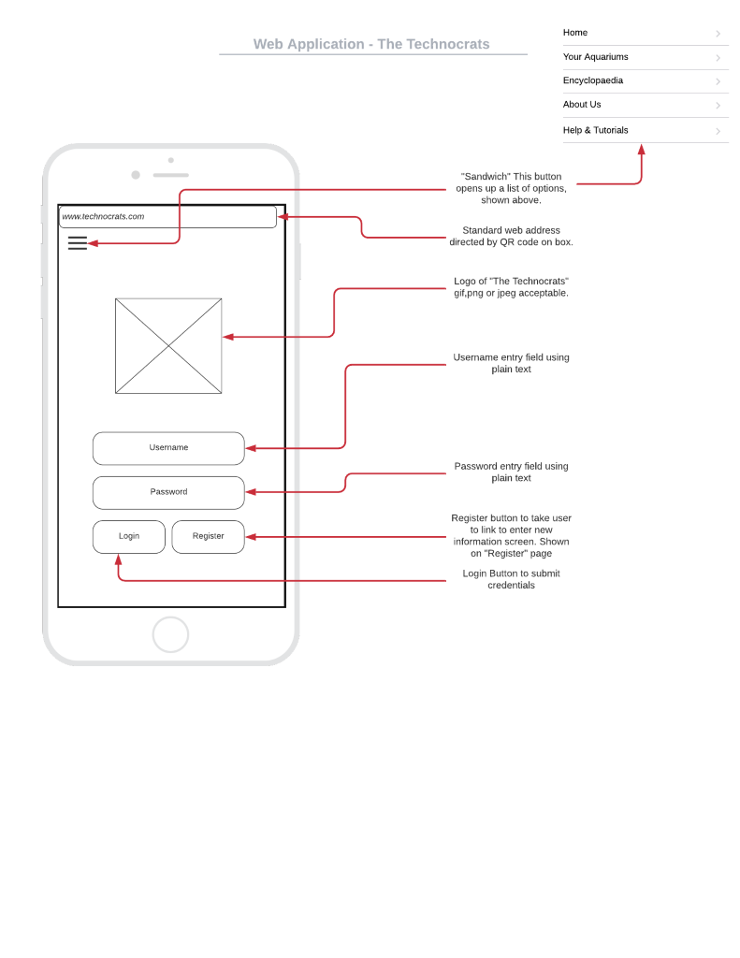

Registration Page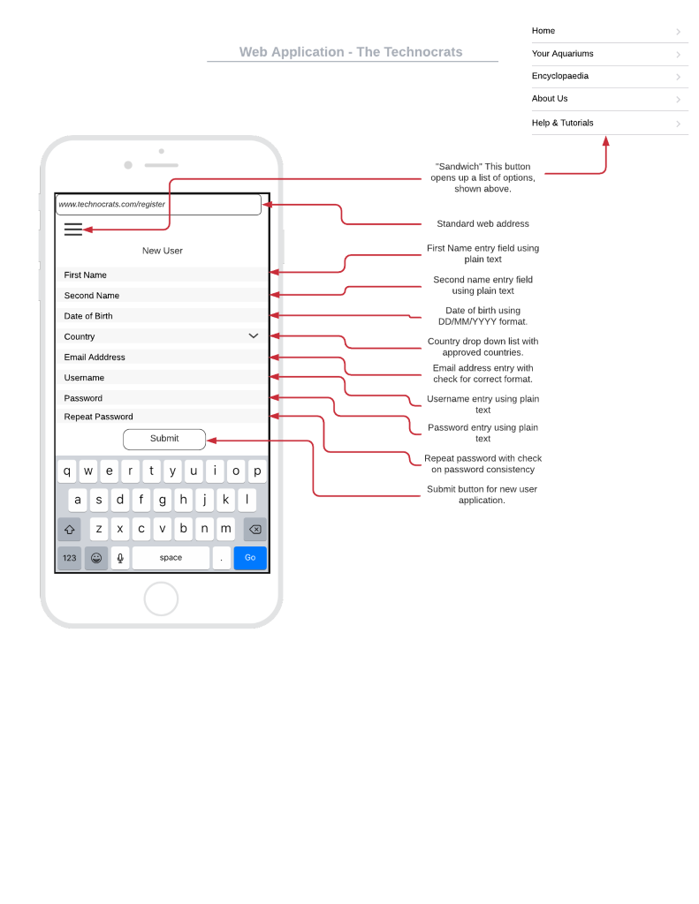

### Setup Page

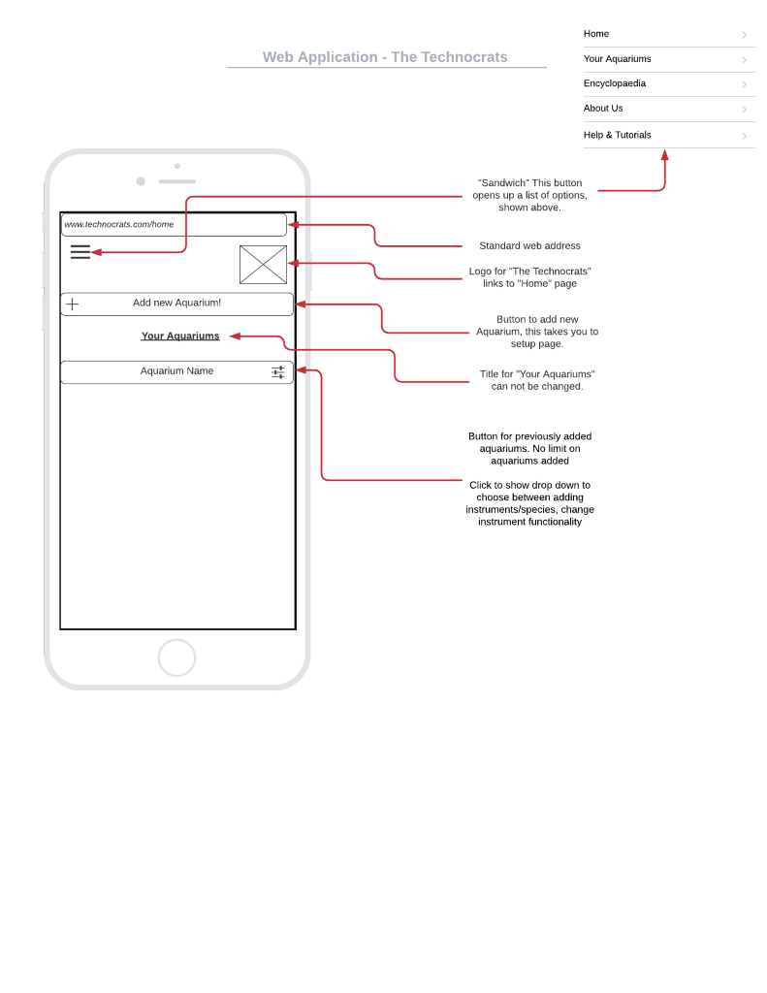

## Companion App Prototype Gallery

Overview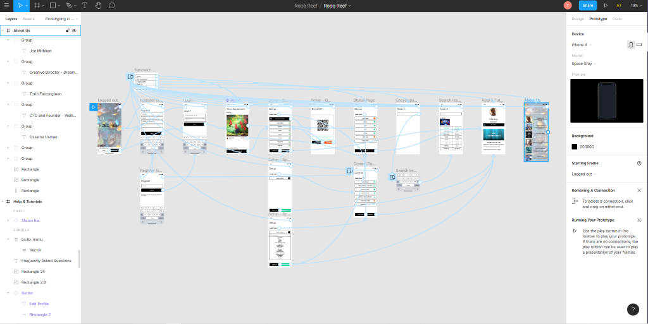

### Landing Page

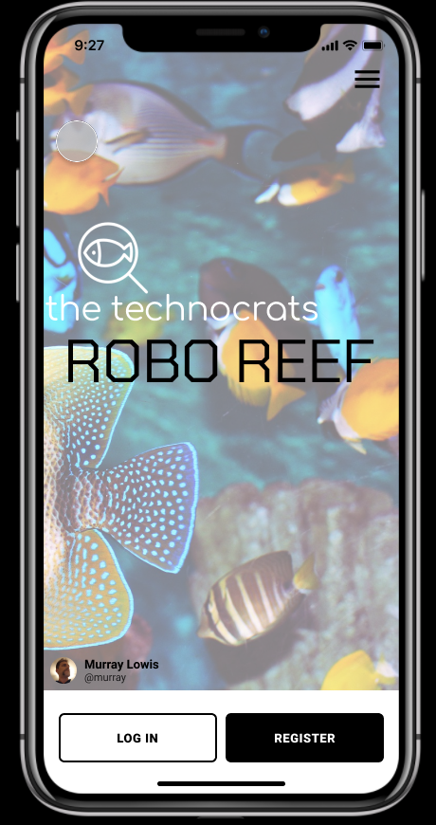

### Registration Page

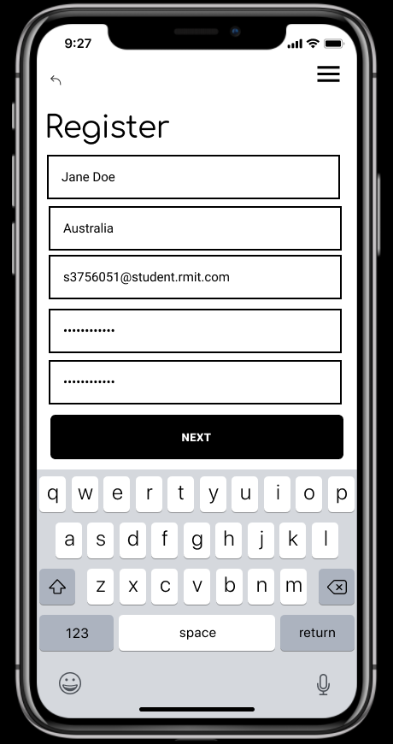

### Log In Page

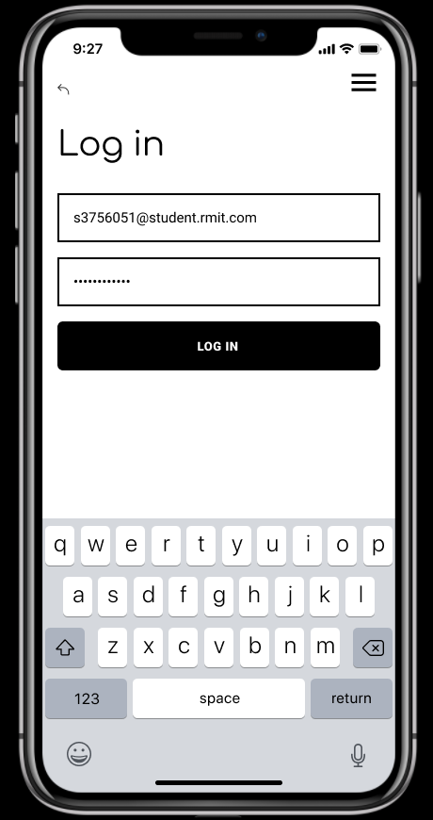

### Home Page

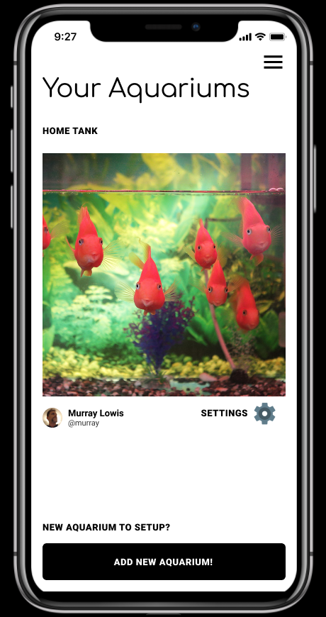

### Instrument Setup Page

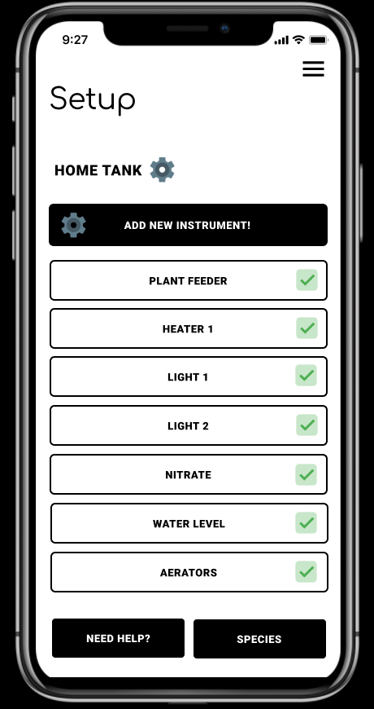

### Species Setup Page

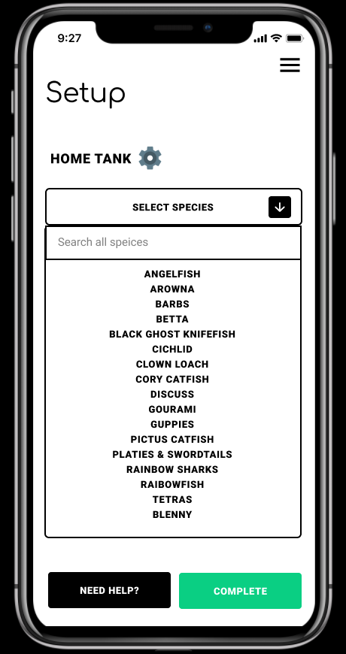

### QR Camera Page

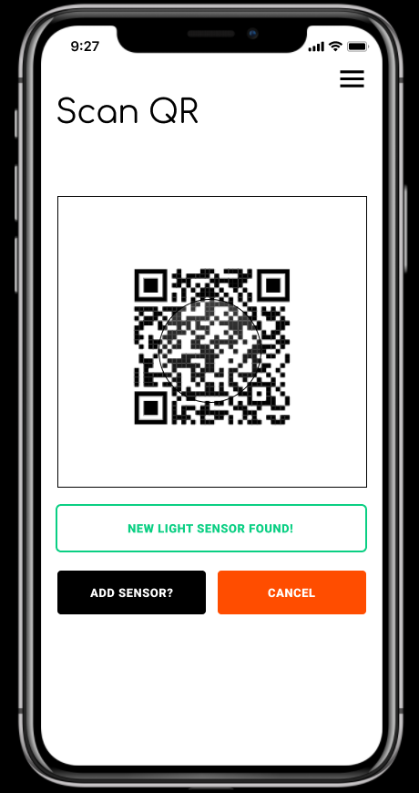

### Status Page

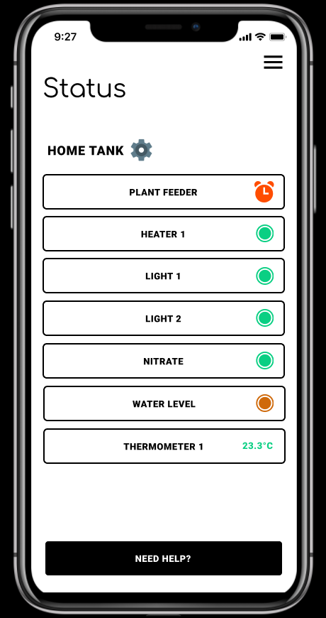

### Control Page

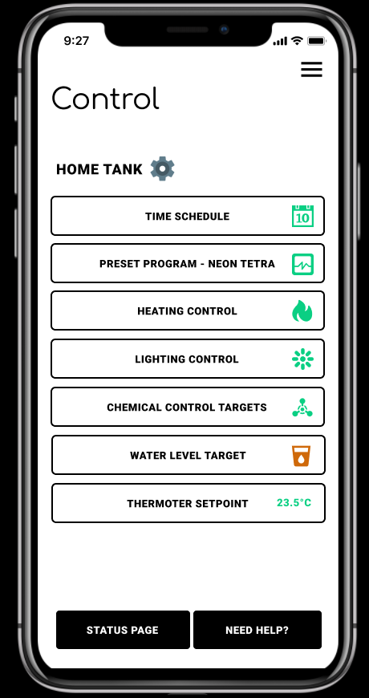

### Search Page

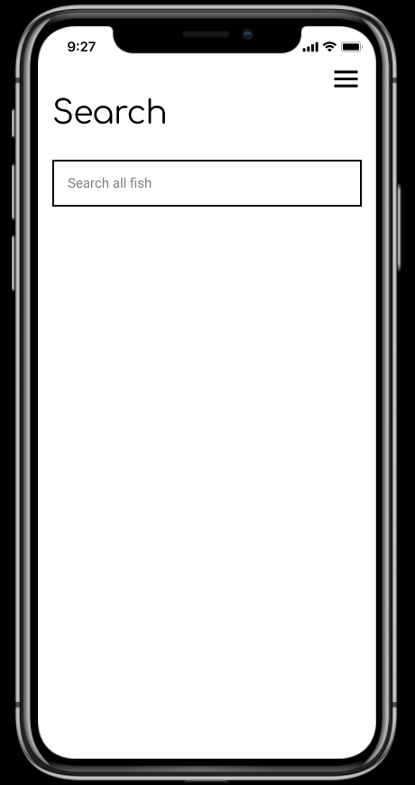

### Encyclopaedia Page

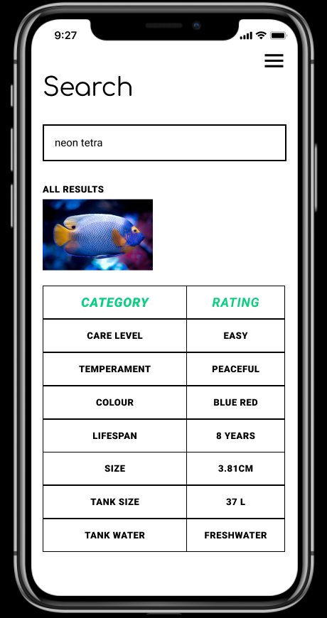

### Help & Tutorials Page

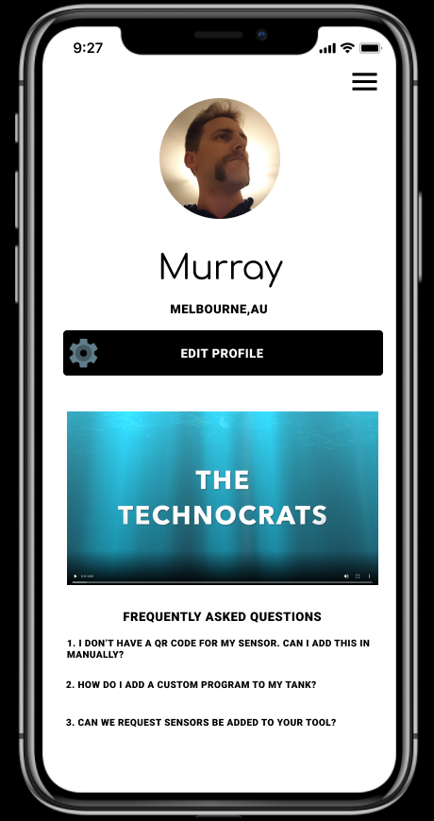

### About Us Page

